# **Online Bookstore – Project setup**

**Link to original repo:** [**shashirajraja/onlinebookstore: The Online Book Shopping Store to manage, buy, add, remove and sell books. Book name and Quantity selection, auto receipt generated and payment options. Login and logout security for both user and admin. Seperate Profile for all.**](https://github.com/shashirajraja/onlinebookstore)

**Note: If the instructions in this doc are a little hard to follow, the directions in the original repo link are formatted better and might be clearer. The setup for the tomcat server and MySQL can be a bit tricky so the videos can be helpful.**

* **================ Software And Tools Required ================**
* : Git [<https://www.youtube.com/watch?v=gv7VPQ4LZ7g>]
* : Java JDK 8+ [<https://www.youtube.com/watch?v=O9PWH9SeTTE>]
* : Eclipse EE (Enterprise Edition) [<https://www.youtube.com/watch?v=8aDsEV7txXE>]
* : Apache Maven [<https://www.youtube.com/watch?v=jd2zx3dLjuw>]
* : Tomcat v8.0+ [<https://youtu.be/mLFPodZO8Iw?t=903>]
* : MySQL Server [<https://www.youtube.com/watch?v=Ydh5jYA6Frs>]
* : MySQL Workbench (optional) [<https://www.youtube.com/watch?v=t79oCeTXHwg>]
* **================= Dummy Database Initialization =================**
* STEP 1: Open MySQL Command Prompt or MySQL Workbench
* STEP 2: Login to the administrator user as : mysql -u <username> -p (Enter Password if asked)
* STEP 3: Copy paste the following MySql Commands-

create database if not exists onlinebookstore;

use onlinebookstore;

create table if not exists books(barcode varchar(100) primary key, name varchar(100), author varchar(100), price int, quantity int);

create table if not exists users(username varchar(100) primary key,password varchar(100), firstname varchar(100),

lastname varchar(100),address text, phone varchar(100),mailid varchar(100),usertype int);

insert into books values('9780134190563','The Go Programming Language','Alan A. A. Donovan and Brian W. Kernighan',400,8);

insert into books values('9780133053036','C++ Primer','Stanley Lippman and Josée Lajoie and Barbara Moo',976,13);

insert into books values('9781718500457','The Rust Programming Language','Steve Klabnik and Carol Nichols',560,12);

insert into books values('9781491910740','Head First Java','Kathy Sierra and Bert Bates and Trisha Gee',754,23);

insert into books values('9781492056300','Fluent Python','Luciano Ramalho',1014,5);

insert into books values('9781720043997','The Road to Learn React','Robin Wieruch',239,18);

insert into books values('9780132350884','Clean Code: A Handbook of Agile Software Craftsmanship','Robert C Martin',288,3);

insert into books values('9780132181273','Domain-Driven Design','Eric Evans',560,28);

insert into books values('9781951204006','A Programmers Guide to Computer Science','William Springer',188,4);

insert into books values('9780316204552','The Soul of a New Machine','Tracy Kidder',293,30);

insert into books values('9780132778046','Effective Java','Joshua Bloch',368,21);

insert into books values('9781484255995','Practical Rust Projects','Shing Lyu',257,15);

insert into users values('demo','demo','Demo','User','Demo Home','42502216225','demo@gmail.com',2);

insert into users values('Admin','Admin','Mr.','Admin','Haldia WB','9584552224521','admin@gmail.com',1);

insert into users values('shashi','shashi','Shashi','Raj','Bihar','1236547089','shashi@gmail.com',2);

commit;

* **========== Importing and Running The Project Through Eclipse EE ==========**
* Step 1: Open Eclipse Enterprise Edition. [Install, if not already installed.]
* Step 2. a: Go inside src/main/resources > application.properties and update the

value of database details as per your usage, like db.driver, db.host, db.username and db.password according to your installed mysql/postgresql admin user credentials.

**Ensure both properties files are changed, other is located inside test/resources folder**

* Step 2.b: Right Click on Project > Run as > Maven Build > In the goals field enter "clean install" > apply > run
* Step 2.c: Right Click On Project > Build Path > Configure Build Path > Libraries > Remove and Update Any Libraries if Red Mark Exists > Finish.
* Step 3: [Only If Tomcat Server is not configured in Eclipse] : Right Click On Project > Run As > Run On Server > Select Tomcat V8.0 > (Select Tomcat V8.0 Installation Location If Asked) Next > Add onlinebookstore > Finish.
* Step 4: In The Server Tab > Double Click On Tomcat Server > Ports > Change The Port Number For Http/1.1 To 8083 > Close And Save.
* Step 5: Right Click On Project > Run As > Run On Server > Select Tomcat v8.0 > Next > Add All> Done.
* Step 6: Check Running The Site At <http://localhost:8083/onlinebookstore/>
* Step 7: Default Username And Password For Admin Is "Admin" And "Admin"
* Step 8: The default Username And Password For User Is "shashi" And "shashi"

**NOTE:** these are the instructions for setting up the base project itself from its original repo. The steps that are contained in this doc are still pertinent to setting up the projects for tests. Some of these can be slightly tricky, so attached are a few videos that may help. Since this was a project designed to teach, the set up videos offer some much needed help:

* **Youtube VIDEO** for step by step Local Setup Guide : <https://youtu.be/mLFPodZO8Iw>

**For running White Box Tests:**

**Ensure credentials are updated in properties folder to your sql credentials**

**Run with mvn clean test**

**TO RUN ALL TESTS AND GENERATE JACOCO REPORT:**

**In terminal: mvn clean test jacoco:report**

**To see jacoco report, go into target/site/jacoco and find and index.html file, if you click on the onlinebookstore link after traveling to the website, the full report will be there**

# **Online Bookstore - Black Box Testing Report**

## **Project Information**

* **Project Name**: Online Bookstore
* **Repository**: https://github.com/shashirajraja/onlinebookstore.git
* **Testing Type**: Black Box Testing

## **Test Environment**

* **Operating System**: Windows 10
* **Browser**: Brave
* **Java Version**: JDK 24
* **Server**: Apache Tomcat 9
* **Database**: MySQL 8.0

## **1. User Registration and Login Tests**

### **Test Case 1.1: User Signup/Registration**

* **Description**: Test the user registration functionality
* **Test Steps**:
  1. Navigate to the homepage
  2. Click on "Register" or "Sign Up" button



* 1. Enter valid details:
     + Email: [testuser1@example.com](mailto:testuser1@example.com)
     + Password: testuser1
     + First Name: test
     + Last Name:user
     + Phone: 1234567890
     + Address: 123 Test Street, Test City

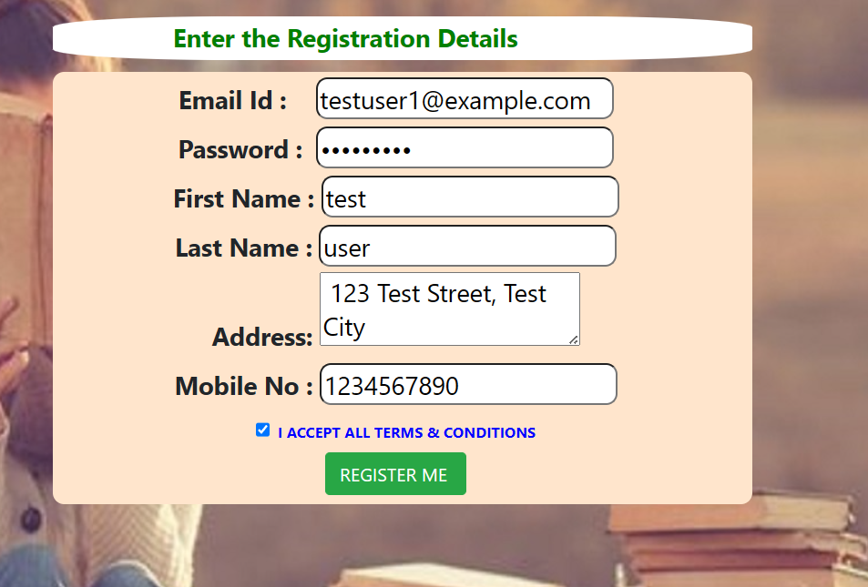

* 1. Submit the form
  2. Observe the success message



* 1. **Expected Result**: Account created successfully message, user able to login with new credentials
* **Actual Result**:Account created successfully
* **Status**: PASS
* **Defects (if any)**:No
* **Notes**:

### **Test Case 1.2: Signup with Existing Username**

* **Description**: Attempt to register with a username that already exists
* **Test Steps**:
  1. Navigate to the registration page
  2. Enter details with an existing username:
     + Email id:shashi
     + Password: shashi
     + First Name:Shashi
     + Last Name:Raj
     + Phone: 1236547089
     + Address: Bihar

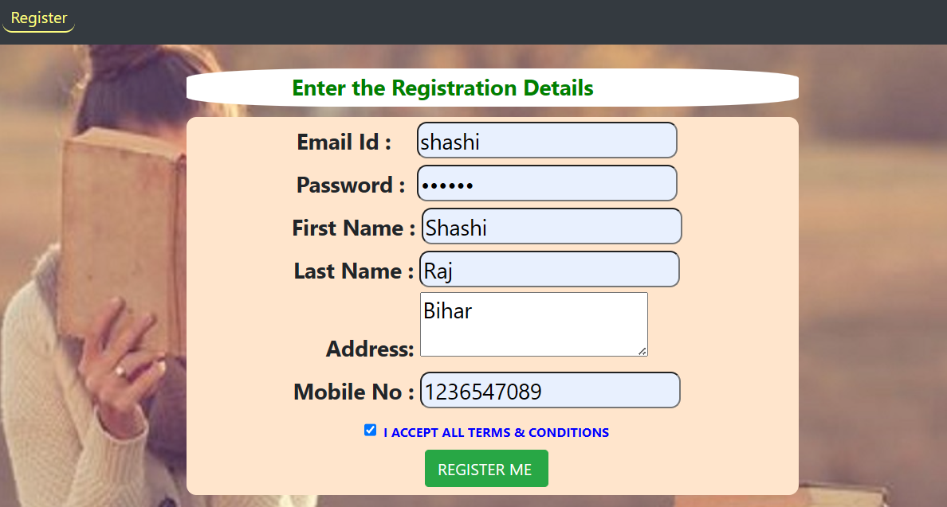

* 1. Submit the form
  2. Observe the error message



* **Expected Result**: Error message indicating username already exists
* **Actual Result**: Error message indicating username already exists
* **Status**: PASS
* **Defects (if any)**:
* **Notes**:

### **Test Case 1.3: Signup with Invalid Data**

* **Description**: Test form validation with invalid data
* **Test Steps**:
  1. Navigate to the registration page
  2. Enter invalid data:
     + Email: te
     + Password: 123
     + First name:te
     + Last name:h
     + Email: invalid-email
     + Phone: abc
     + Address: mmm 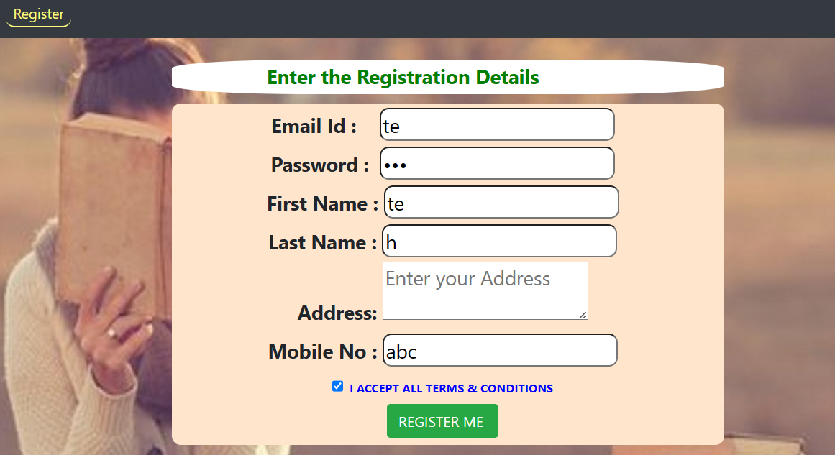
  3. Submit the form
  4. Observe validation messages

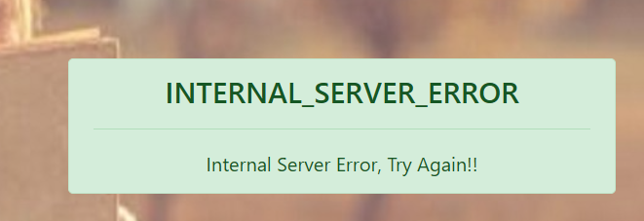

* 1. **Expected Result**: Form validation errors displayed
* **Actual Result**:Server crash
* **Status**: FAIL
* **Defects:**Internal server error occurs when alphabetic characters are entered in the phone number field. The application fails to properly validate input and crashes instead of displaying a user-friendly error message.
* **Notes**:

### **Test Case 1.4: User Login (Valid Credentials)**

* **Description**: Test the login functionality with valid credentials
* **Test Steps**:
  1. Navigate to the login page [SCREENSHOT: Login_Page]
  2. Enter valid username and password:
     + Username: testuser1
     + Password: Test@123

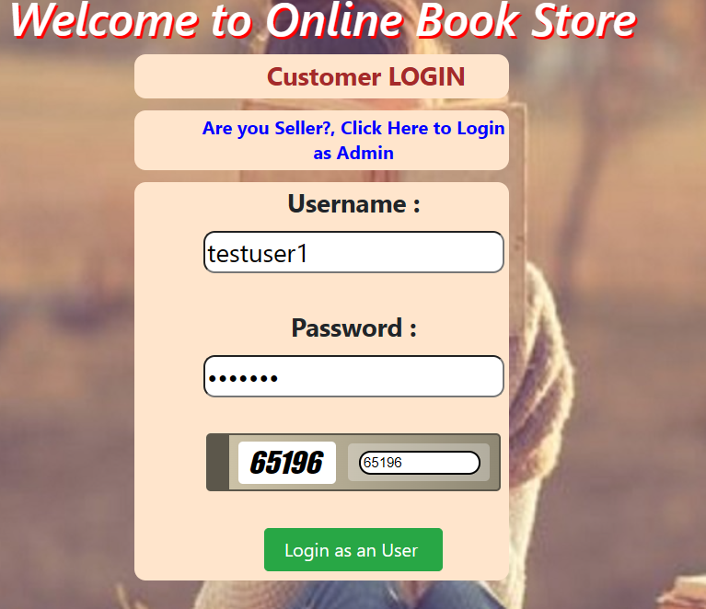

* + - Click on login button
  1. Observe successful login



* **Expected Result**: User successfully logged in and redirected to homepage
* **Actual Result**: User successfully logged in and redirected to homepage
* **Status**: PASS
* **Defects (if any)**:None
* **Notes**:

### **Test Case 1.5: User Login (Invalid Credentials)**

* **Description**: Test the login functionality with invalid credentials
* **Test Steps**:
  1. Navigate to the login page
  2. Enter invalid username or password:
     + Username: testuser1
     + Password: wrongpassword

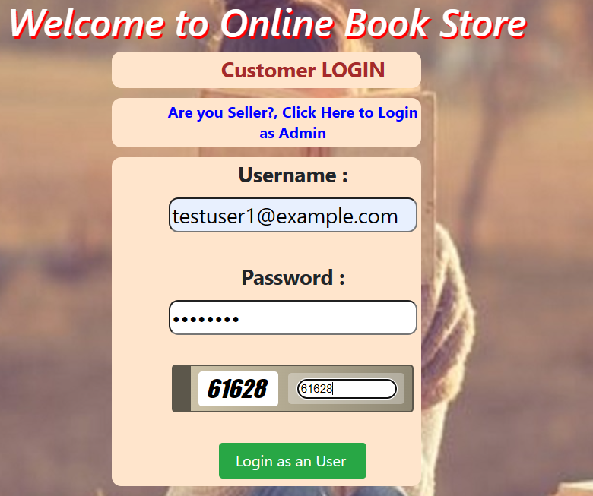

* 1. Click on login button
  2. Observe error message



* **Expected Result**: Error message indicating invalid credentials
* **Actual Result**: Error message indicating invalid credentials
* **Status**: PASS
* **Defects (if any)**:None
* **Notes**:

## **2. Book Browsing Tests**

### **Test Case 2.1: View All Books**

* **Description**: Verify that all books are displayed on the homepage
* **Test Steps**:
  1. Navigate to the homepage after login
  2. Check if books are displayed



* 1. **Expected Result**: List of available books displayed with details (name, author, price)
* **Actual Result**:List of available books displayed with details (name, author, price)
* **Status**: PASS
* **Defects (if any)**:None
* **Notes**:

## **3. Shopping Cart Tests**

### **Test Case 3.1: Add Book to Cart**

* **Description**: Test adding a book to the shopping cart
* **Test Steps**:
  1. Navigate to the homepage
  2. Select a book
  3. Click "Add to Cart" button



* 1. Observe confirmation

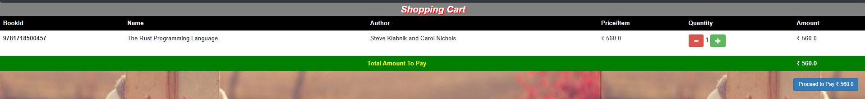

* 1. **Expected Result**: Book added to cart, cart item count updated
* **Actual Result**:Book added to cart, cart item count updated
* **Status**: PASS
* **Defects (if any)**:None
* **Notes**:

### **Test Case 3.2: View Cart**

* **Description**: Test viewing the shopping cart
* **Test Steps**:
  1. Add items to cart (as in Test Case 3.1)
  2. Click on "View Cart" or cart icon



* 1. Observe cart contents



* **Expected Result**: Cart page displays with all added items, quantities and prices
* **Actual Result**:Cart page displays with all added items, quantities and prices
* **Status**: PASS
* **Defects (if any)**:
* **Notes**:

### **Test Case 3.3: Update Book Quantity in Cart**

* **Description**: Test updating book quantity in the cart
* **Test Steps**:
  1. Navigate to cart page with items
  2. Update quantity using "+"/"-" buttons or input field

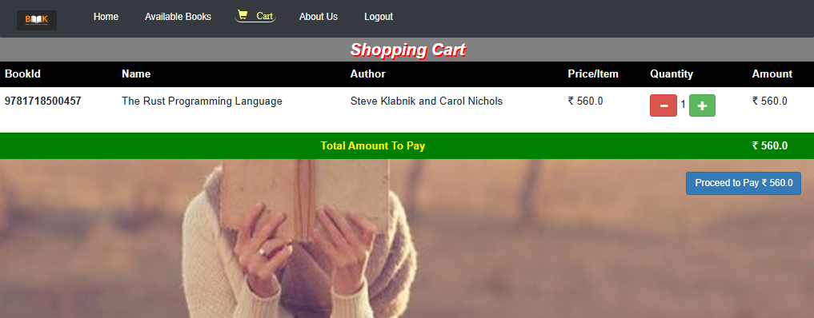

* 1. Click "Update" if required
  2. Observe updated cart

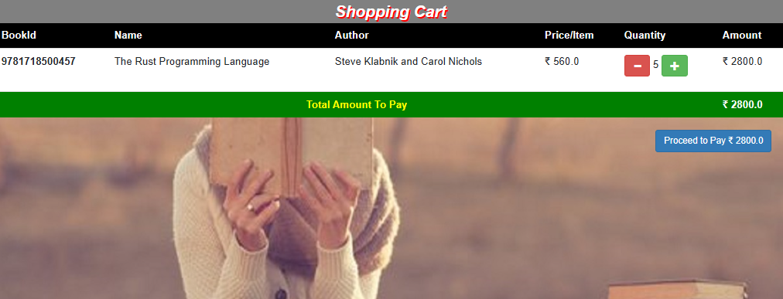

* **Expected Result**: Quantity updated, cart total price updated accordingly
* **Actual Result**:Quantity updated, cart total price updated accordingly
* **Status**: PASS
* **Defects** :None
* **Notes**:

## **4. Checkout Process Tests**

### **Test Case 4.1: Checkout with Valid Information**

* **Description**: Test the checkout process with valid payment information
* **Test Steps**:
  1. Add books to cart
  2. Navigate to cart page
  3. Click "Checkout" button



* 1. Enter valid shipping details if prompted

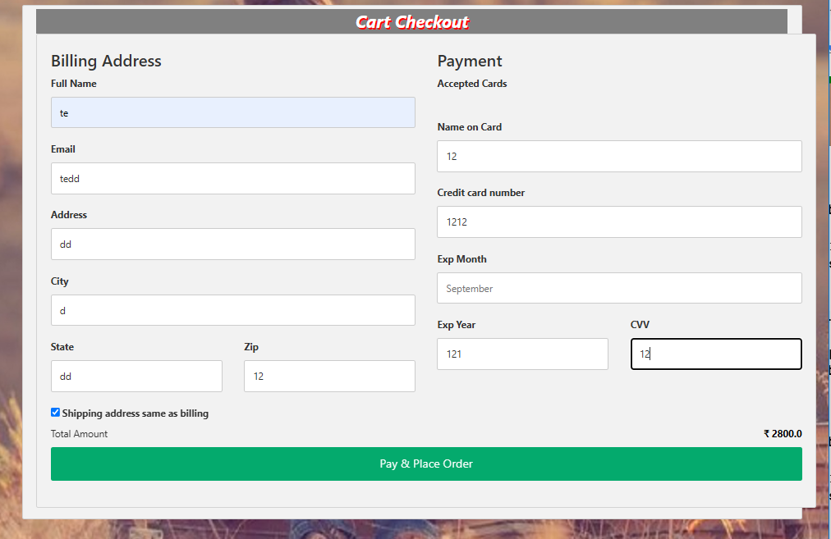

* 1. Observe order confirmation

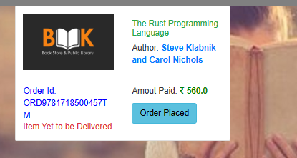

* **Expected Result**: Order card displayed in orders page
* **Actual Result**: Order card displayed in orders page
* **Status**: PASS
* **Defects (if any)**:
* **Notes**:

### **Test Case 4.2: Checkout with Empty Cart**

* **Description**: Attempt to checkout with an empty cart
* **Test Steps**:
  1. Ensure cart is empty
  2. Navigate to cart page

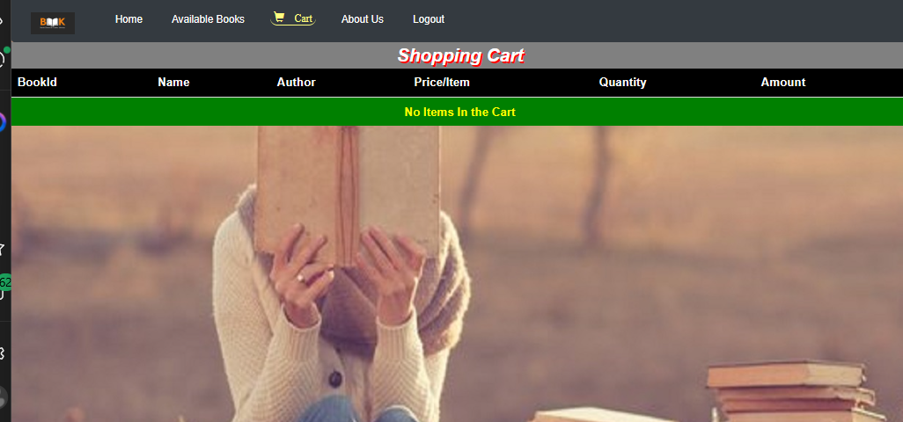

* 1. Observe checkout button status



* **Expected Result**:disabled checkout button
* **Actual Result**:disabled checkout button
* **Status**: PASS
* **Defects (if any)**:None
* **Notes**:

## **5. Admin Functionality Tests**

### **Test Case 5.1: Admin Login**

* **Description**: Test admin login functionality
* **Test Steps**:
  1. Navigate to admin login page

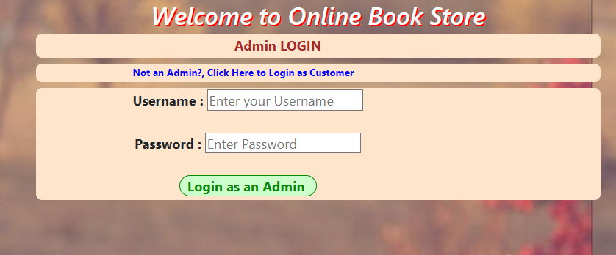

* 1. Enter valid admin credentials:
     + Username: admin
     + Password: admin
  2. Observe admin dashboard



* **Expected Result**: Admin successfully logged in and redirected to admin dashboard
* **Actual Result**:Admin successfully logged in and redirected to admin dashboard
* **Status**: PASS
* **Defects (if any)**:None
* **Notes**:

### **Test Case 5.2: Add New Book**

* **Description**: Test adding a new book to the inventory
* **Test Steps**:
  1. Log in as admin
  2. Navigate to "Add Book" section



* 1. Fill in book details:
     + Book name: "Test Book"
     + Author: "Test Author"
     + Price: $29.99
     + Quantity: 10

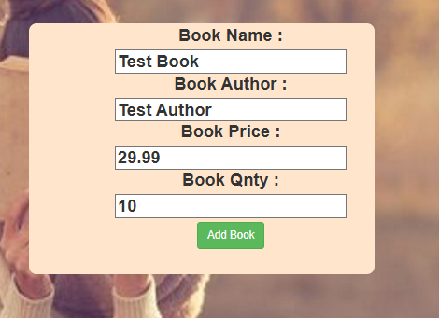

* 1. Click "Add" or "Submit" button
  2. Observe success message and updated inventory



* 1. **Expected Result**: Success message, book appears in inventory
* **Actual Result**:Success message, book appears in inventory
* **Status**: PASS
* **Defects (if any)**:
* **Notes**:

### **Test Case 5.3: Remove Book**

* **Description**: Test removing a book from inventory
* **Test Steps**:
  1. Log in as admin
  2. Navigate to book inventory
  3. Select a book to delete

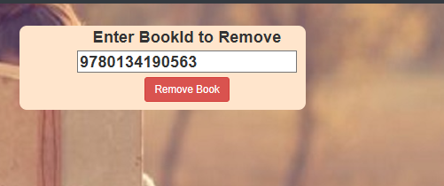

* 1. Click "Delete" or "Remove" button
  2. Observe updated inventory

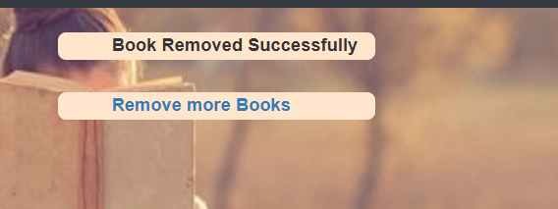

* **Expected Result**: Book removed from inventory
* **Actual Result**:Book removed from inventory
* **Status**: PASS
* **Defects (if any)**:None
* **Notes**:

## **Test Summary**

|  |  |  |  |
| --- | --- | --- | --- |
| **Test Case ID** | **Feature** | **Status** | **Defects Found** |
|  |  |  |  |
| 1.1 | User Registration | Pass | No |
| 1.2 | Registration (Duplicate) | Pass | No |
| 1.3 | Registration (Invalid) | Fail | DEF-001 |
| 1.4 | User Login (Valid) | Pass | No |
| 1.5 | User Login (Invalid) | Pass | No |
| 2.1 | View Books | Pass | No |
| 3.1 | Add to Cart | Pass | No |
| 3.2 | View card | Pass | No |
| 3.3 | Updated Card | Pass | No |
| 4.1 | checkout | Pass | No |
| 4.2 | Empty Cart Checkou | Pass | No |
| 5.1 | Admin Login | Pass | No |
| 5.2 | Add Book | Pass | No |
| 5.3 | Remove book | Pass | No |

# **Online Bookstore -WhiteBox Testing with Junit**

## **Packages and Classes Tested**

After analyzing the repository structure, the following packages and classes were identified and targeted for white box testing:

1. **Model Classes**:
   * com.bittercode.model.Book
   * com.bittercode.model.User
   * com.bittercode.model.UserRole
2. **Service Classes**:
   * com.bittercode.service.BookServiceImpl
   * com.bittercode.service.UserServiceImpl
3. **Utility Classes**:
   * com.bittercode.util.DBUtil
4. **Servlet Classes**:
   * LoginServlet

## **Testing Approach**

### **Unit Testing**

1. **Model Classes**:
   * Tested getter and setter methods for correct functionality
   * Tested object initialization and default values
   * Verified toString() method output for proper formatting
2. **Service Classes**:
   * Used Mockito to isolate database operations
   * Tested CRUD operations for books and users
   * Verified exception handling for edge cases
   * Tested business logic independently from database
3. **Utility Classes**:
   * Tested database connection establishment and closure
   * Verified connection pooling works correctly
4. **Servlet Classes**:
   * Mocked HTTP requests and responses
   * Tested authentication logic
   * Verified session management
   * Tested request dispatching to appropriate views

### **Test Coverage**

## **Testing Results**

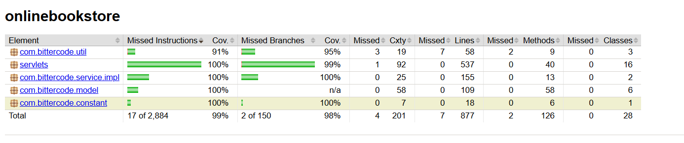

### **Successful Tests**

* Basic model operations (getters/setters) work correctly
* Database connections can be established and closed properly
* User authentication logic functions as expected
* Book retrieval by barcode works correctly

### **Identified Issues**

1. **Input Validation**: No validation for empty fields in book creation
2. **Error Handling**: Some methods don't properly handle SQL exceptions
3. **Connection Management**: Potential resource leaks in database connection handling
4. **Missing Null Checks**: Several methods don't check for null parameters

**Packages and Classes Tested:**

**Model Classes (com.bittercode.model):**

Book

User

UserRole

Cart

Address

**Service Classes (com.bittercode.service):**

BookServiceImpl

UserServiceImpl

**Utility Classes (com.bittercode.util):**

DBUtil

DatabaseConfig

StoreUtil

**Constant and Exception Classes:**

ResponseCode

StoreException

**Servlet Classes (servlets):**

AboutServlet

AddBookServlet

BuyBooksServlet

CartServlet

CheckoutServlet

CustomerLoginServlet

CustomerRegisterServlet

ErrorHandlerServlet

LogoutServlet

ProcessPaymentServlet

ReceiptServlet

RemoveBookServlet

SellerLoginServlet

StoreBookServlet

UpdateBookServlet

ViewBookServlet

**Testing Approach:**

**1. Unit Testing of Models:**

Tested constructors, getters, and setters.

Verified object creation and default behavior.

**2. Service Layer Testing:**

Mocked database interactions using Mockito.

Tested CRUD operations on books and users.

Simulated failure scenarios (e.g., SQLException, invalid user registration).

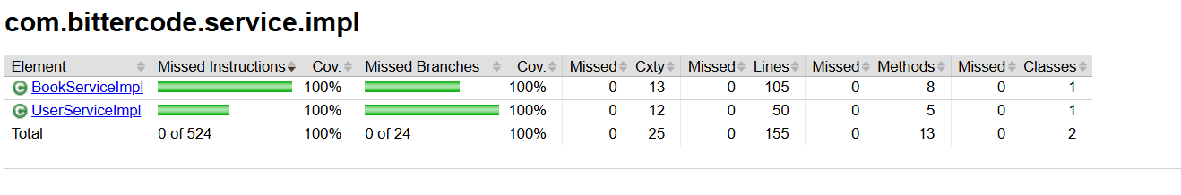

**3. Utility Testing:**

Verified database configurations and connection establishment.

Static block exception handling documented but not forcibly tested due to Java limitations.

**DatabaseConfig.java**

Despite thorough testing, full 100% code coverage for DatabaseConfig.java could not be achieved without modifying the original source file. This is because the static block in DatabaseConfig executes only once when the class is first loaded, and Java does not allow static blocks to be re-executed during testing. While all static fields and normal loading paths were tested successfully, the catch block for handling IOException during property loading could not be triggered again after class loading. Therefore, the current testing covers all meaningful execution paths, and the minor gap is due to Java's static initialization behavior, not an issue with the code or tests themselves.

**DBUtil.java**

It is not possible to achieve full coverage for DBUtil.java without changing or corrupting the application.properties file. However, corrupting application.properties causes DBUtil's static block to fail when the class is loaded, marking DBUtil as broken in memory. As a result, other classes like BookService and UserService that rely on DBUtil also fail to run properly. Since Java does not allow reloading a static block once a class is loaded, maintaining a valid application.properties file is necessary to ensure the application and all tests work. Therefore, full coverage for exception paths inside the static blocks cannot be achieved without disrupting the rest of the system.

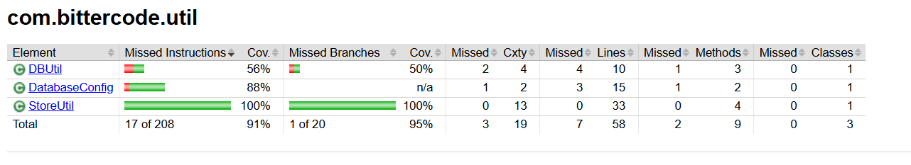

**4. Constants and Exception Testing:**

Validated ResponseCode mappings.

Tested StoreException behavior for different error scenarios.

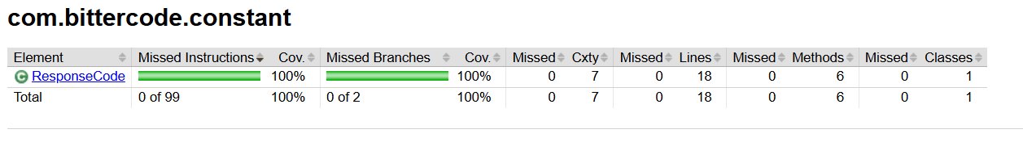

**5. Servlet Testing:**

Used JUnit and Mockito to simulate HTTP requests and responses.

Mocked HttpServletRequest, HttpServletResponse, HttpSession, and RequestDispatcher.

Tested key operations:

User login and registration flows (CustomerLoginServlet, CustomerRegisterServlet, SellerLoginServlet).

Cart operations (CartServlet, BuyBooksServlet).

Book management (add, remove, update, view - AddBookServlet, RemoveBookServlet, UpdateBookServlet, ViewBookServlet).

Checkout and Payment (CheckoutServlet, ProcessPaymentServlet, ReceiptServlet).

Miscellaneous flows (AboutServlet, StoreBookServlet, LogoutServlet, ErrorHandlerServlet).

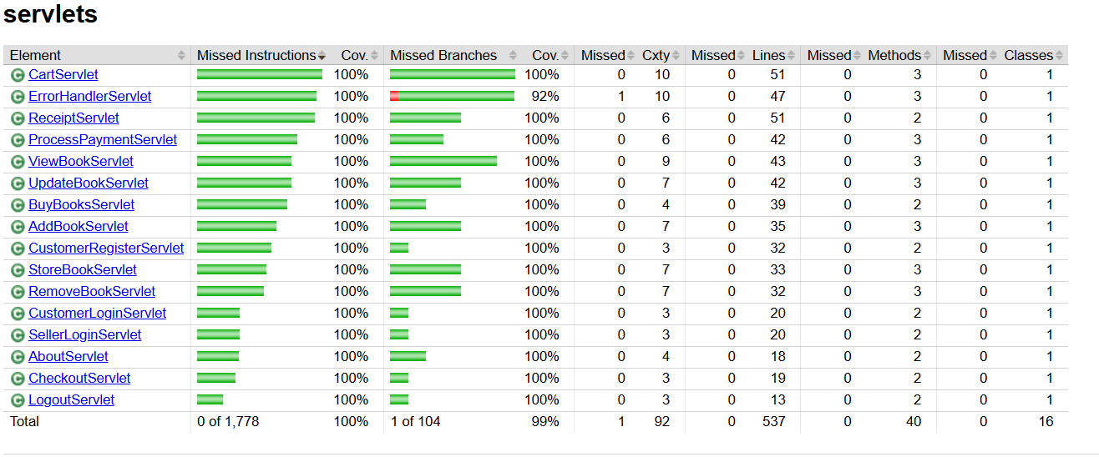

**Servlet Overview**

The goal was to achieve complete test coverage for the servlet code in the online bookstore application. The servlets are responsible for handling important parts of the system such as customer login, seller login, book management, cart handling, payment processing, and error handling. Each servlet had different responsibilities. Some servlets forwarded users to the appropriate pages based on their login roles, while others updated session attributes, processed book orders, or managed system errors gracefully.

To test the servlets properly, we designed tests that could cover all logical branches, all method executions, and all exception handling paths inside each servlet. We aimed to simulate real-world user interactions and system behaviors, making sure that no major behavior was left untested.

**How We Achieved Full Coverage**

We achieved full coverage by carefully thinking about how users or the system could trigger different behaviors. For every servlet, we tested successful scenarios, edge cases, and error conditions. Successful scenarios included actions like a customer logging in properly, a seller adding a book successfully, or a payment being processed without issues. Edge cases involved situations where form fields were missing, cart items were empty, or quantities were invalid. Error conditions included cases where exceptions were thrown by the service layer or when a servlet encountered missing session attributes.

In order to do this, we used Mockito to mock request, response, and session objects. We also used static mocking to control the behavior of utility methods like StoreUtil.isLoggedIn() and StoreUtil.setActiveTab(). After every set of tests, we generated a JaCoCo coverage report to see if any branches or paths were still uncovered. If the report showed a missed branch, we wrote specific additional tests that directly triggered that branch until all possible meaningful paths were covered.

**Challenges Faced**

One of the biggest challenges we faced was dealing with code that had logical branches that were technically unreachable. A good example of this was in the ErrorHandlerServlet class, where there was a check written as if (storeException != null). In practice, storeException is created by casting a non-null throwable to a StoreException. Since Java does not allow a successful cast to produce a null value, it is impossible to reach a situation where storeException would be null unless the original throwable itself was null, which the servlet already checks for separately.

Because of this, even though JaCoCo showed that one branch inside the if (storeException != null) was uncovered, there was no realistic way to create a test case for it without changing the original servlet code. We chose not to change the servlet code, because doing so would complicate the application unnecessarily and introduce code that has no real use. The defensive null check inside the servlet is fine from a safety point of view but does not realistically require a separate test. Therefore, we decided to leave that specific branch uncovered, accepting that it is logically unreachable and does not affect the correctness of the application.

**What the Tests Show**

The tests show that all user types, including customers, sellers, and unregistered visitors, are handled properly by the servlets. They confirm that session management, such as storing, retrieving, and removing items from the session, works correctly across different user actions. The tests also confirm that form handling is reliable, with the servlets correctly reading parameters such as book IDs, names, quantities, and responding appropriately when these parameters are missing or invalid. Exception handling was tested thoroughly, showing that the servlets can catch exceptions and display appropriate user-friendly error messages instead of crashing.

The tests also validated that all important conditional logic was working. Different paths were triggered depending on whether users were logged in or not, whether books were available or out of stock, and whether selections were made by users. Business rules, such as preventing users from buying a quantity greater than the available stock, were also fully tested and confirmed to be enforced properly. Overall, the tests proved that the servlet layer of the application behaves predictably, safely, and robustly, even when users or the system make unexpected moves.

# **Online Bookstore – Load Testing Report**

**Setup:**

* **Have project running on localhost:8080**
* **Ensure apache jmeter is installed**
* **Set up proxy according to browser/system**
  + **Ensure certificate is trusted for jmeter to run**
* **Run the test plan**
* **Results stored in the aggregate reports for each thread group**
* **In the jmeter folder included in the submission is a csv required for the tests, ensure that it is located in your jmeter /bin folder**

**Userflows:**

* Admin login
* Admin create/update/remove book
* Customer login
* Customer add book to cart
* Customer checkout

# **Online Bookstore – GUI Testing Report**

**Setup:**

* Follow the base project setup steps, although the copying of the original repo is not required.
* **Important:** The default localhost link set up in the project variables is on port 8080, if this is not the port you selected when starting the server, either change the port to be 8080 or update the variable in the guiTests.java file
* Navigate to [**SWTDB-FinalProjectCJNidheesh**](https://github.com/cparadi3/SWTDB-FinalProjectCJNidheesh/tree/main)/[onlinebookstore-master](https://github.com/cparadi3/SWTDB-FinalProjectCJNidheesh/tree/main/onlinebookstore-master)/[src](https://github.com/cparadi3/SWTDB-FinalProjectCJNidheesh/tree/main/onlinebookstore-master/src)/[test](https://github.com/cparadi3/SWTDB-FinalProjectCJNidheesh/tree/main/onlinebookstore-master/src/test)/[java](https://github.com/cparadi3/SWTDB-FinalProjectCJNidheesh/tree/main/onlinebookstore-master/src/test/java)/**guiTests.java**
* Start the apache tomcat server
* Build project
  + Right click onlinebookstoremaster -> run as -> maven build … -> in goals enter “test” - > run
* Test results in console under “junit” tab
* Test report under SWTDB-FinalProjectCJNidheesh/onlinebookstore-master/src/target/surefirereports
* To check coverage, right click guiTests.java -> coverage as -> junit
* **Only the tests marked in red on the excel sheet are expected to throw an error, if others produce one, try running it as a solo test, for some reason this fixes some issues with google password manager alerts.**

**Userflows tested**

* Unlogged in navigation
* Admin login
* Admin logout
* Admin add book
* Admin update book
* Admin remove book
* Customer login
* Customer add book to cart
* Customer checkout book
* Customer remove book from cart
* Register new user
* Login new user
* Admin add book, customer check visibility of new book
* Admin remove book, customer check visibility of book
* Admin update book, customer check visibility of book
* Login/Register with missing/incorrect info

**Easier to read test report located in the spreadsheet provided in the submission files.**